Nama : Fajrul Falah

NIM : 21120117120033

Halaman awal

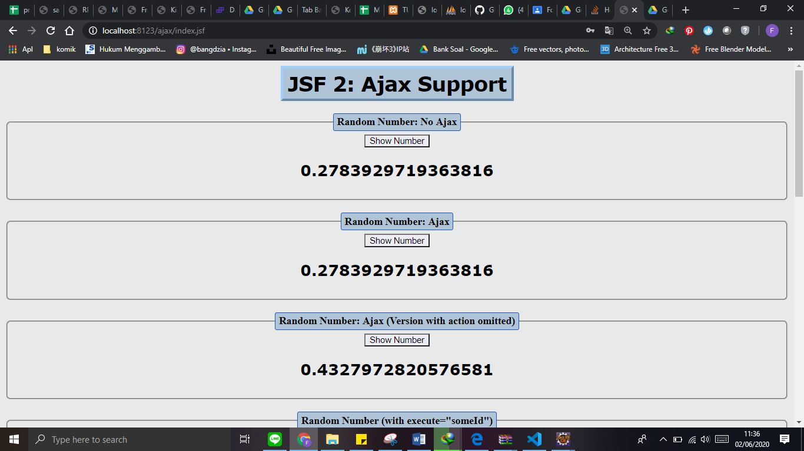

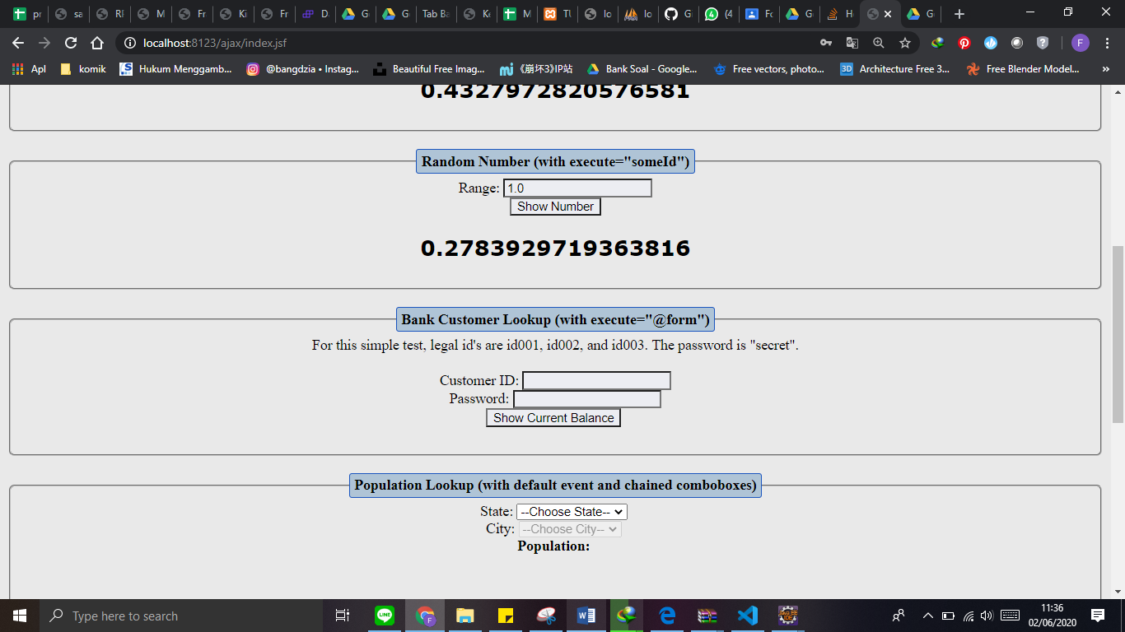 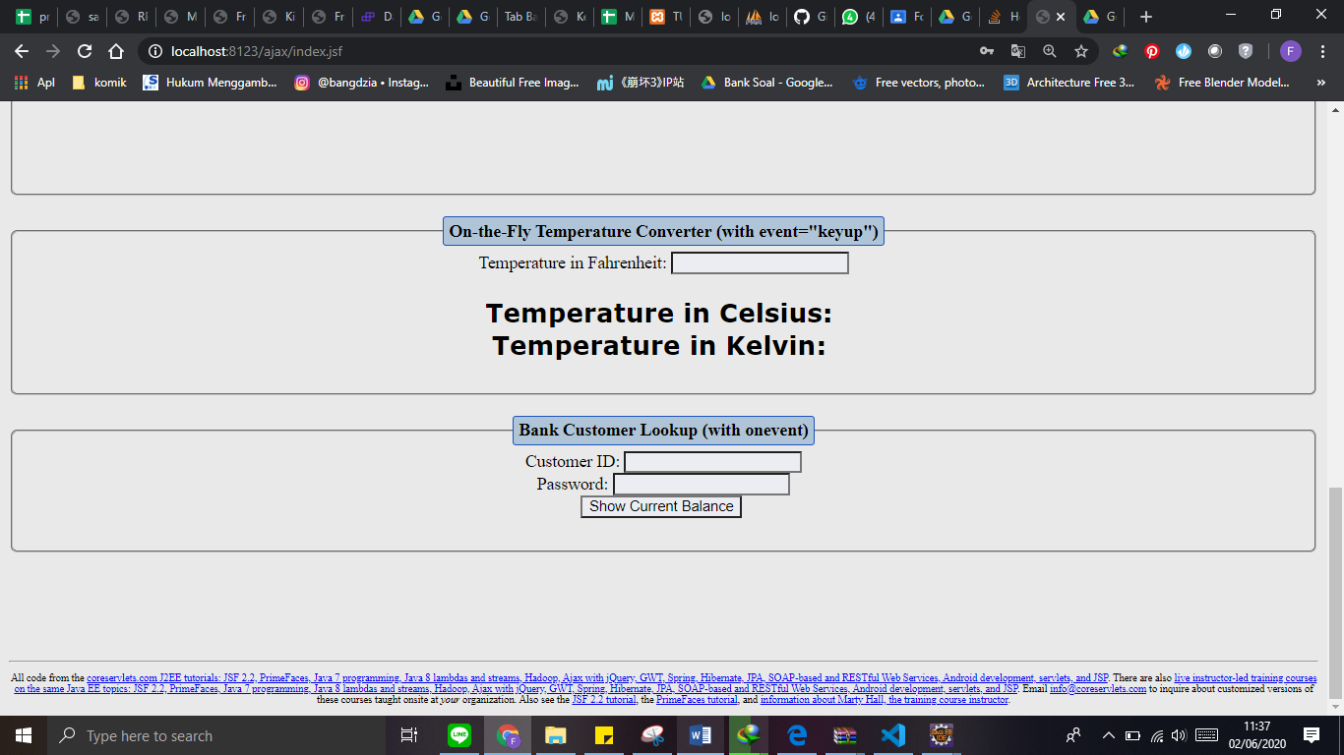

Ketiga button show number diawala setelah ditekan

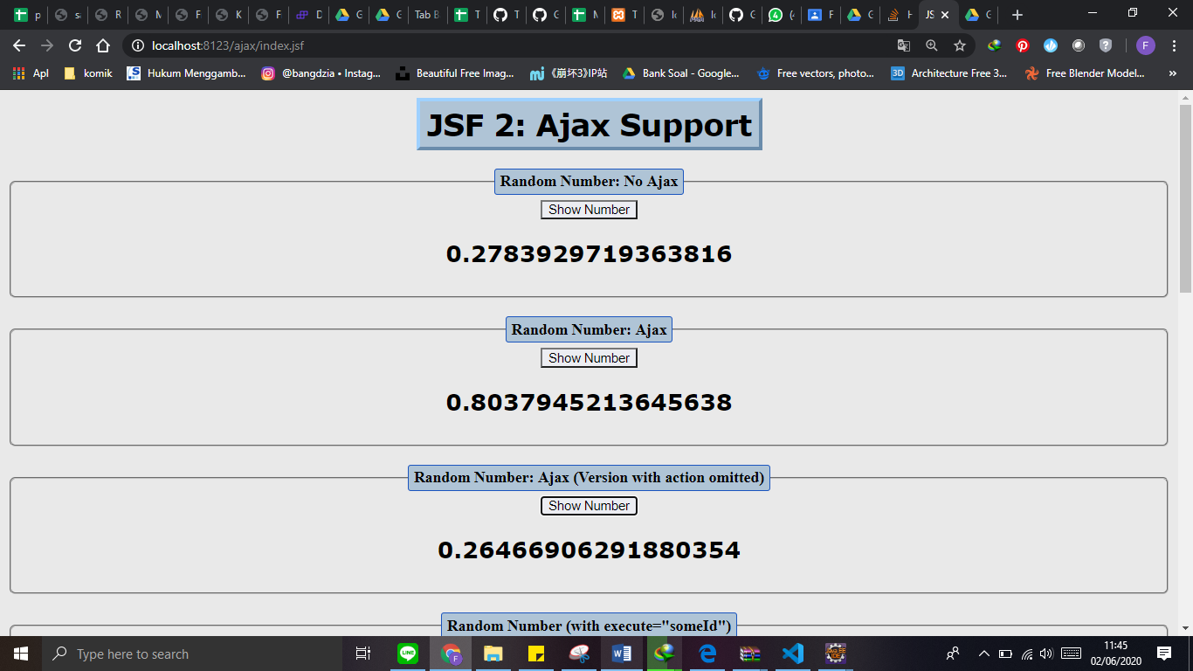

Random Number (with execute="someId")

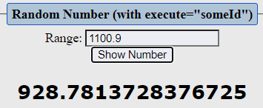

Bank Customer Lookup (with execute="@form")

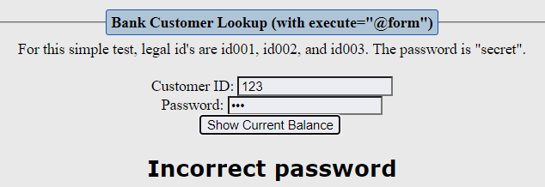

Population Lookup (with default event and chained comboboxes)

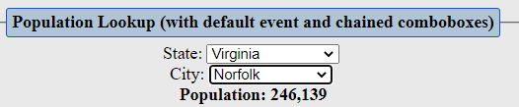

On-the-Fly Temperature Converter (with event="keyup")

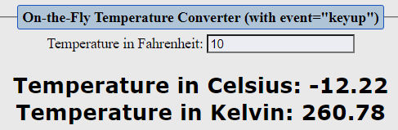

Bank Customer Lookup (with onevent)

